**EXIT TICKETS - 3.2.1 h,i - Functional Ecosystems; Keystone Species – ANSWERS**

1. Define the term Keystone Species (3.2.1 h) [1]. A plant or animal that plays a unique and crucial role in the way an ecosystem functions
2. The diagram below is a food web of biota for the pacific northwest of North America. (3.2.1 i)

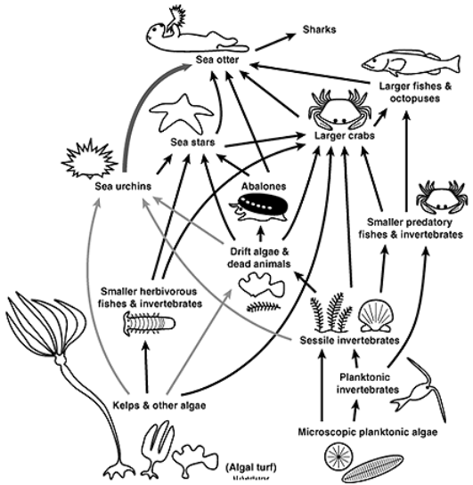

1. **Analyse** the given information to **identify** the keystone species. Briefly **justify** your choice. [2]

|  |
| --- |
| Sea Otter. This can be assumed as they are an apex predator that consumes the full range of mesopredator (secondary consumers) and sea urchins. This predation prevents over consumption of producers or primary consumers. |

1. **Predict** the outcome for the ecosystem of removing the keystone species. Give a reason. [2]

|  |
| --- |
| The ecosystem would collapse. A range of its prey species would increase in number. In the case of the sea urchin this may result in the destruction of algal populations that are important for a range of other species. |